Rittal offers future-proof cooling units and chillers
New playbook for refrigerants
Herborn/Germany, 21. April 2026
In 2027, new EU regulations will take effect that further restrict the use of refrigerants in new machinery. In the future, many refrigerants will be banned from sale. This will affect many machines and systems in which enclosure cooling units or chillers are installed. Rittal offers a variety of cooling unit series using the new refrigerant R-1234yf, so that machine manufacturers can future-proof their products, in most cases without further modifications.
From 1 January 2027, EU Regulation 2024/573 will restrict the use of refrigerants in cooling units and chillers with a cooling output below 12 kW. Only cooling units with a refrigerant GWP (Global Warming Potential) of less than 150 may then be marketed in the EU. From 2032 onwards, it will no longer be possible to use any refrigerants containing fluorinated gases (F-gases) in these products. Chillers with a cooling output of over 12 kW that are placed on the market starting in 2027 should use only refrigerants with a GWP <750. Further international regulations, such as those in the USA, have set a GWP of 700 for refrigerants in these appliances since 2025.

Compliance with regulations without any great effort
Rittal responded to the increasingly stringent limits as early as 2024, converting every cooling unit and chiller to the refrigerant R-513A, a mixture of R-134a and R-1234yf, so achieving a GWP of 631. This way, such devices will retain their internationally approved status until further notice. Starting in the first quarter of 2026, the Blue e+ cooling unit portfolio will then be converted to R-1234yf, followed by the Blue e+ series of chillers in the second quarter. “This means that climate control units from Rittal will definitely comply with international regulations until 2032, and we will also have suitable solutions for our customers in good time to meet the requirements applying from 2032,” confirms Ralf Schneider, Head of Solution Sales Climate Control at Rittal.

New refrigerants with a higher fire risk

However, when installing refrigeration systems, it must be borne in mind that the flammability of refrigerants increases as the GWP decreases. “Although R-1234yf is flammable, it only ignites at temperatures above 400 °C and is thus classed as low flammability (safety class A2L),” Ralf Schneider explains. The risk analysis carried out by Rittal on the use of this refrigerant in enclosure cooling units resulted in a “low risk” assessment.

In the automotive industry, a variety of investigations and tests have been carried out on the use of R-1234yf. The results show a higher overall risk than when using R-134a, though no significant increase in the risk of accidents overall. In Japan, R-1234yf has been used in enclosure cooling units and other cooling systems for many years because, unlike with F-gases, regular maintenance is not needed. Since 2018, Rittal has been supplying units filled with R-1234yf to this market and has thus gained extensive experience with the substance. This means that, for the foreseeable future, machine manufacturers can continue to use Rittal’s cooling units and chillers in enclosures and other applications without any major modifications, enabling them to market their systems worldwide in compliance with regulations.

Future-proof product range is guaranteed

With its Blue e+ cooling units using the new refrigerant R-1234yf, Rittal already ensures full compliance with the F-gas specifications, while simultaneously minimising cost risks. This is because refrigerants with a higher GWP, such as R-513A, are becoming increasingly rare and expensive due to the stricter quotas. This means that switching to R-1234yf early also ensures a secure long-term supply, especially after the significant reductions set to take effect in 2027.

Thanks to UL and IEC certifications, the very low A2L charge sizes and a safety-optimised device design, the units can be used worldwide without any further safety measures. The appropriate certificates can be downloaded from the Rittal website (www.rittal.com).

Rittal offers its customers a complete, future-proof product range covering every application. The cooling unit and chiller technologies provide a sustainable, energy-efficient and long-term viable solution – far more than a mere transitional technology. Units are still available with R-513A (GWP 631) as refrigerant for special cases in which operators document an unacceptable risk in their application.

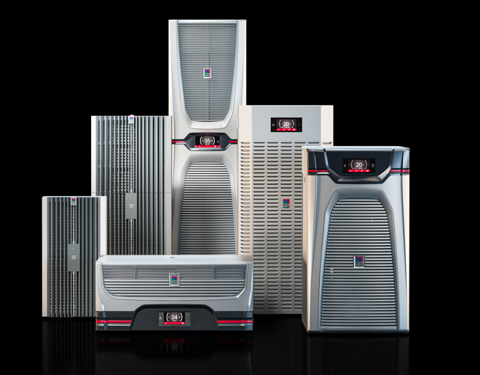 |  | 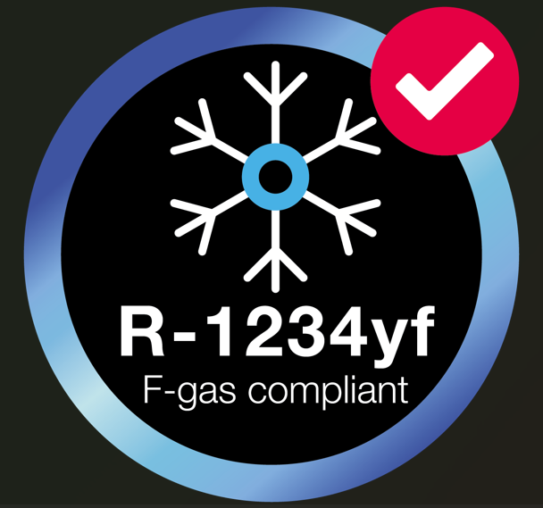
Image 1  Starting in the first quarter of 2026, the Blue e+ cooling unit range will be converted to R-1234yf. The Blue e+ series of chillers will follow in the second quarter. |  | Image 2 en black / Image 3 en white  Rittal offers a variety of cooling unit series using the new refrigerant R-1234yf, so that machine manufacturers can future-proof their products, in most cases without further modifications.

May be reproduced free of charge. Please name Rittal GmbH & Co. KG as the source

Rittal

Rittal is a leading global supplier of enclosure systems, automation and infrastructure with its industrial, IT, energy and power, cooling and service units. Rittal products and solutions are used in over 90% of global industries – standardised, customised, and always of the very best quality.

Our approach and methodology: Rittal, Rittal Software Systems (Eplan, Cideon) and Rittal Automation Systems (RAS, Ehrt, Alfra) combine their hardware and software expertise to streamline, optimise and industiralise processes across the entire value chain of their customers including their IT infrastructure – from control and switchgear construction, machine building to manufacturing companies or the energy sector.

Our delivery promise: Rittal standard products are delivered in Germany within 24 hours, and within 48 hours throughout Europe.
Focus on the customer
Improving efficiency and increasing productivity through automation and digitalisation is one of the biggest challenges for our customers. This requires in-depth knowledge and expertise, the combination of hardware and software, and cross-sector networking. We are convinced that creating and connecting data rooms is crucial to the success of industrial transformation. And that is exactly our speciality and field of competence.

Eplan and Rittal are driving the development of the digital automation twin, making data accessible and useable in operations as well. Cideon is improving data consistency in the digital product twin context with its CAD/CAM, PDM/PLM and product configuration expertise.
Sustainability
Environmental and climate protection, social responsibility and ethical corporate governance are a matter of course for Rittal. We take our ownership and accountability for a sustainable future seriously. Our commitment to resource management and conservation includes continuous improvement of our own production processes, minimising the carbon footprint of our products and providing solutions that support and help our customers to achieve their own climate goals.
Family business and global player
Founded in 1961, Rittal is the largest company in the owner-operated Friedhelm Loh Group. The group operates worldwide, with 13 production sites and 95 international subsidiaries. It has 12,600 employees and posted revenues of 3.1 billion euros in fiscal 2024. In 2023, the Friedhelm Loh Group was presented with the “Best Place to Learn” and “Employer of the Future” awards. In 2026, Rittal was awarded the Top 100 Seal as one of Germany’s most innovative medium-sized companies for the fifth time in a row. In 2025, the Rittal plant in Haiger won overall first place in the independent and highly-prestigious “Factory of the Year” competition, which recognised it as a hallmark of manufacturing excellence and one of the best factories in Europe.

For more information, visit www.rittal.com and www.friedhelm-loh-group.com.

Corporate & Brand Communications

Cornelia Müller Hans Robert Koch Steffen Maltzan
Tel. +49 2772 505-2527 Tel. +49 2772 505-2693 Tel. +49 2772 505-2680
E-Mail: mueller.co@rittal.de Mail: koch.hr@rittal.de Mail: maltzan.s@rittal.de

Rittal GmbH & Co. KG, Auf dem Stützelberg, 35745 Herborn

